**System Architecture Diagram**

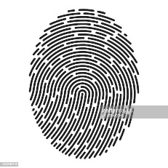

ID: 117

ID: 117

Matching

Feature Extraction

Web Camara

Biometric Sensor

Database

Web Camara

Feature Extraction

Biometric Sensor

Enrollment

Authentication

Account Access